**Operating System**

**UINX Shell**

**Harshjit Jaswal**

**0827CY221022**

**4th Sem**

**Objective:** Case study of UNIX shell.

The Unix shell serves as a crucial interface between users and the operating system in Unix-like environments. Among the various shells available, Bash (Bourne Again Shell) stands out as the most prevalent, with its extensive features and scripting capabilities making it a go-to choose for many users. However, alternatives like Zsh, Ksh, Csh, and Fish offer their unique features, catering to different user preferences and requirements. Whether it's navigating file systems, running commands, or automating tasks through scripting, Unix shells provide a powerful and flexible means of interacting with the underlying system, empowering users to efficiently manage their computing environments.

**Basic Commands of UNIX**

* **ls-** Lists your files  
  **ls -l** --- lists your files in 'long format', which contains lots of useful information, e.g. the exact size of the file, who owns the file and who has the right to look at it, and when it was last modified.  
  **ls -a**--- lists all files, including the ones whose filenames begin in a dot, which you do not always want to see.  
  There are many more options, for example to list files by size, by date, recursively etc.



ls command is showing list of the files – “Red”, “colour”, “harshjit”, “name”

* **cd-** Change directory. You basically 'go' to another directory, and you will see the files in that directory when you do 'ls'. You always start out in your 'home directory', and you can get back there by typing 'cd' without arguments. 'cd ..' will get you one level up from your current position.

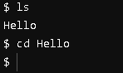

* **pwd-** Tells you where you currently are.

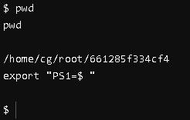

* **mkdir- *dirname*** make a new directory

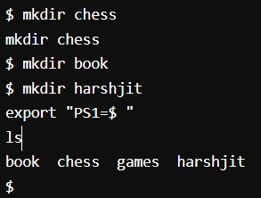

We have created multiple directories, “chess”, “harshjit”, “book”, “games”.

It is confirmed by “ls” command.

* **rmdir-** The rmdir command is used in command-line interfaces to remove directories (folders).

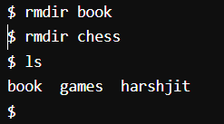

Removing “lost” and “Hello” directory and confirming through ls command.

See earlier through mkdir we made these directories and displayed through ls, now using rmdir we removed two of them.

* **touch-** Command is used to create empty files or update the timestamp of existing files in Unix/Linux systems.

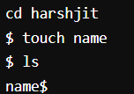

* **echo-** The echo command is used in Unix/Linux and Windows command-line interfaces to display text or print messages to the terminal. It's a simple yet powerful command for displaying output**.**



This command will add “My name is Harshjit” to name file.

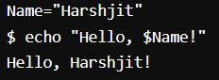

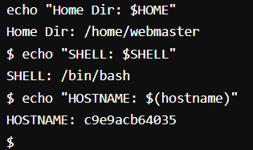

We can also get the username, host, shell, directory using echo.

* **cat-** The cat command, short for "concatenate," is used in Unix/Linux environments to display the contents of files or concatenate files and display the result.

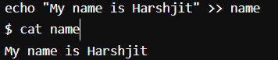

This is displaying the content of “name” file i.e. “my name is Harshjit”.

* **cp-** To copy files and directories from one location to another.

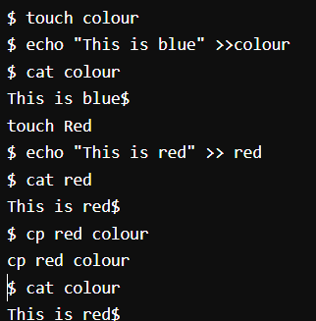

Here we have made two files “colour” and “red” using touch command and added some text in both.

Now, using “cp” command we will replace from red (source) to colour (destination).

Earlier Colour- “This is blue”

Red- “This is red”

After cp, Colour- “This is red”

Here we replaced the content from colour to the content of red.

* **grep-** The grep command is a powerful tool used in Unix/Linux environments and Unix-like operating systems for searching text patterns within files or streams.
* **grep-i:** This command performs a case-insensitive search for the specified "pattern" within the "filename".
* **grep-w:** This command searches for whole word matches of the specified "pattern" within the "filename".
* **grep-c:** This command counts the number of lines that contain the specified "pattern" within the "filename".

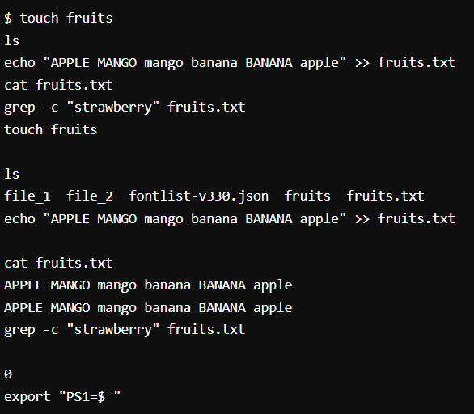

Create a file “fruit” and add “APPLE MANGO mango banana BANANA apple”.

Using grep-c we can find the count of words.

Here we used “strawberry” as it wasn’t in the file therefore the count was zero.

* **Script for adding prefix in old file name:**

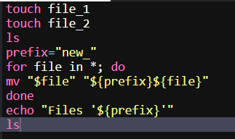

Created two files “file_1” and “file_2” then add “new_” as the prefix to all the files.

As result, first the name of the files of was “file_1” and “file_2” and after the prefix file name change to: “new_file_1” and “new_file_2”

